**3rd Annual Conference on Academic Research in Education (CARE)**

February 25-26, 2019

Sponsored by the University of Nevada at Las Vegas (UNLV), College of Education

The Flamingo Hotel, Las Vegas, Nevada

[Conference Website](https://www.care-conference.net/)

Our **purpose** is. . .

•to examine and explain Vygotsky’s Principal Principles, HEAPS, & spiral staircase (20 minutes)

•to demonstrate how to integrate these constructs into classroom practice through newsletters (15 minutes with 5 minutes for Q&A)

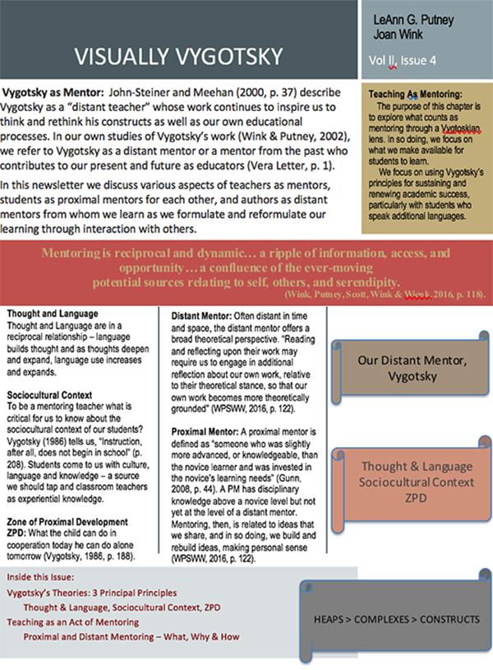

***Reformulating Vygotsky’s Principal Principles into Visual Representation: Newsletters from the Field***

LeAnn Putney, Ph.D. and Joan Wink, Ph.D.

Tuesday, February 26, 12:00 to 1 p.m., Reno 1

**ABSTRACT**

This workshop demonstrates using visual material in the form of newsletters to make abstract concepts more relatable to learners. Utilizing Vygotsky’s theories, we first share his pedagogical concepts through graphic representations in Power Point to clarify and construct local meanings of his work. We then demonstrate how to turn complex information into a shareable newsletter format that we have found to be a conceptual bridge between the academic language of research and conceptual texts and oral lecture. The newsletter format links in-class lecture with outside of class readings and becomes a way of scaffolding learning among students. The newsletters also may become an outcome or product of project-based learning in K-20+ educational settings.

Thought & Language

Sociocultural Context

ZPD

Sociocutua;

**THREE PRINCIPAL PRINCIPLES**

1. Language & Thought

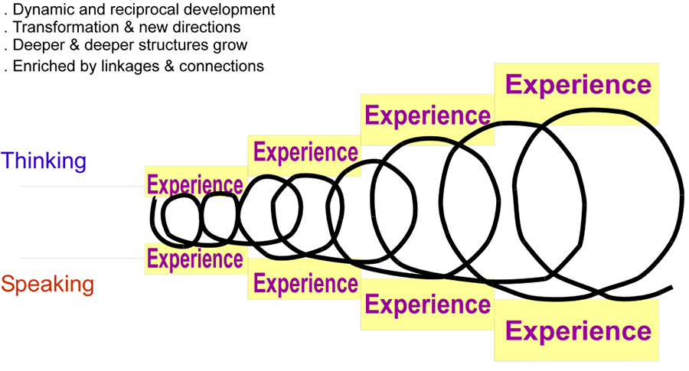

3. ZPD

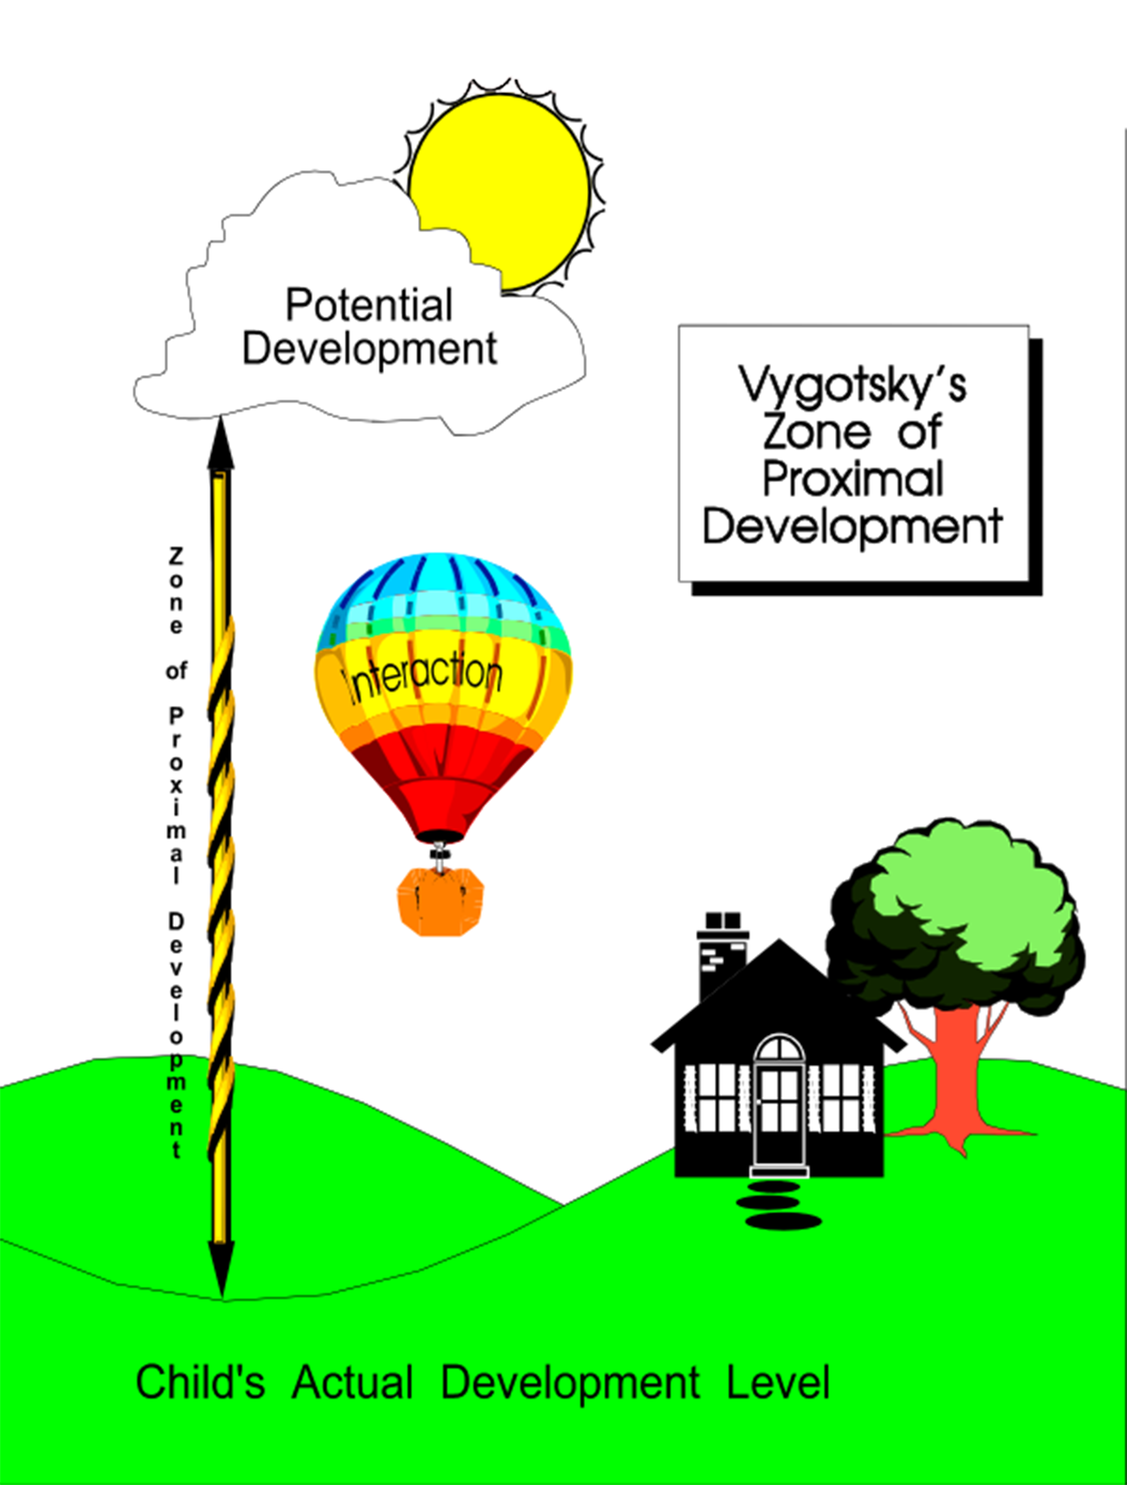

2. Sociocultural Context

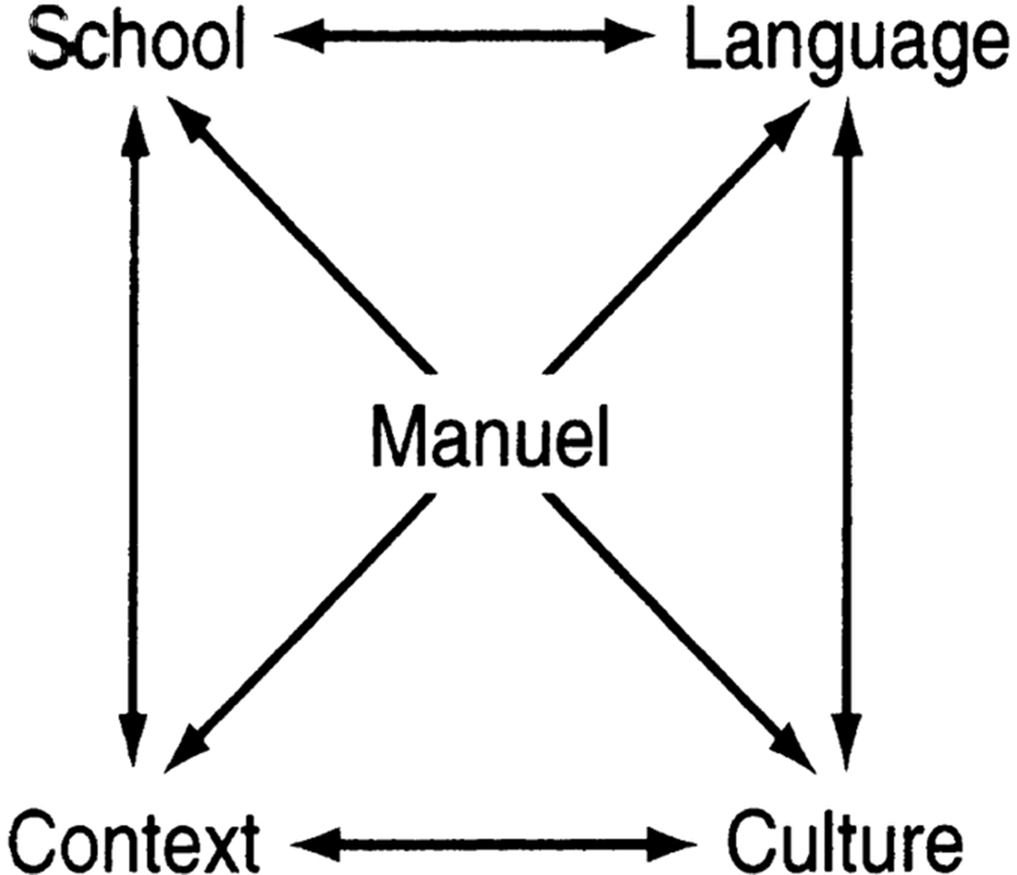

Integrating All Three

**VYGOTSKY’S PRINCIPAL PRINCIPLES RELATED TO CONCEPT DEVELOPMENT**

**HEAPS**



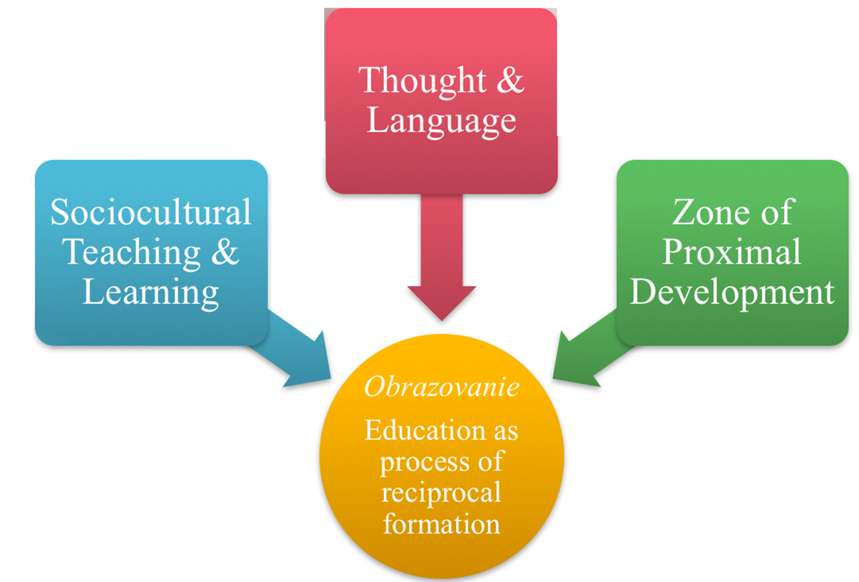

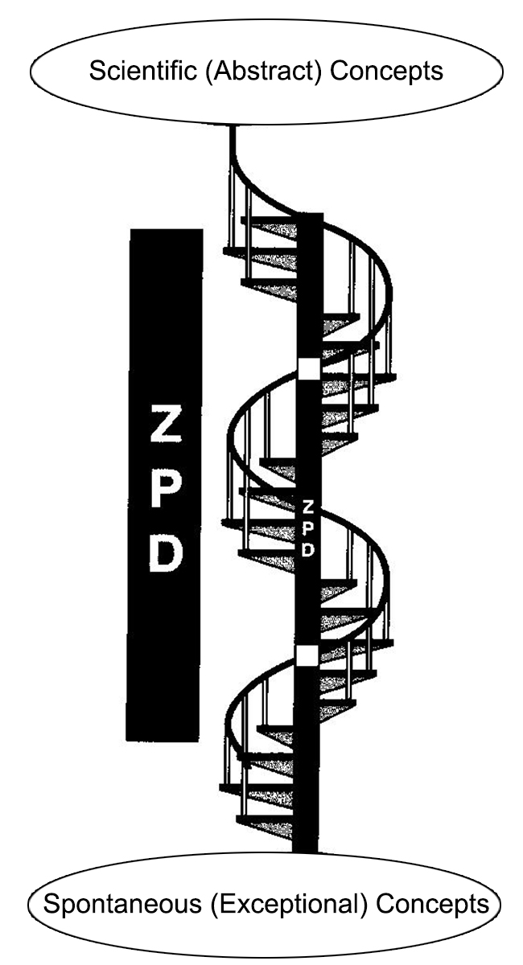

**SPIRAL STAIRCASE**

As spontaneous concepts work upward, they clear a path for scientific concepts to become realized.

Where they meet defines the ZPD.

**INTEGRATING VYGOTSKY INTO YOUR**

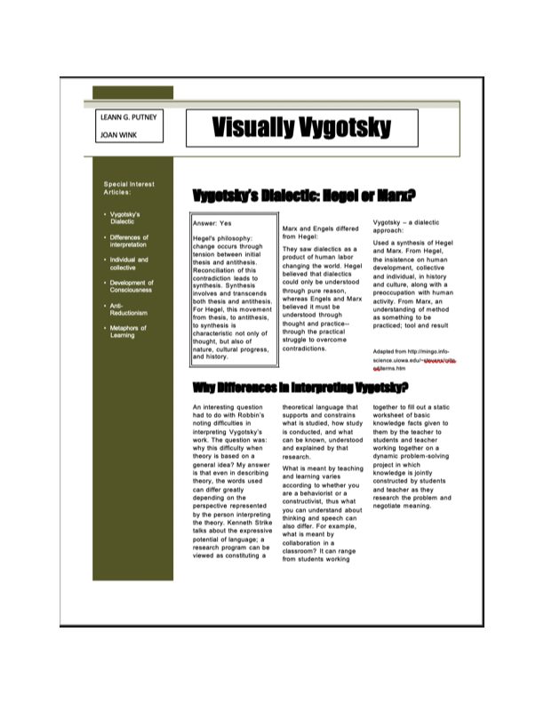**CLASSROOM WITH NEWSLETTER EXAMPLES:**

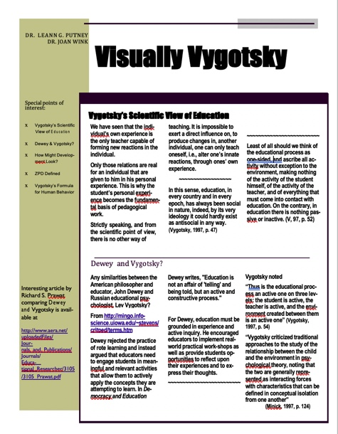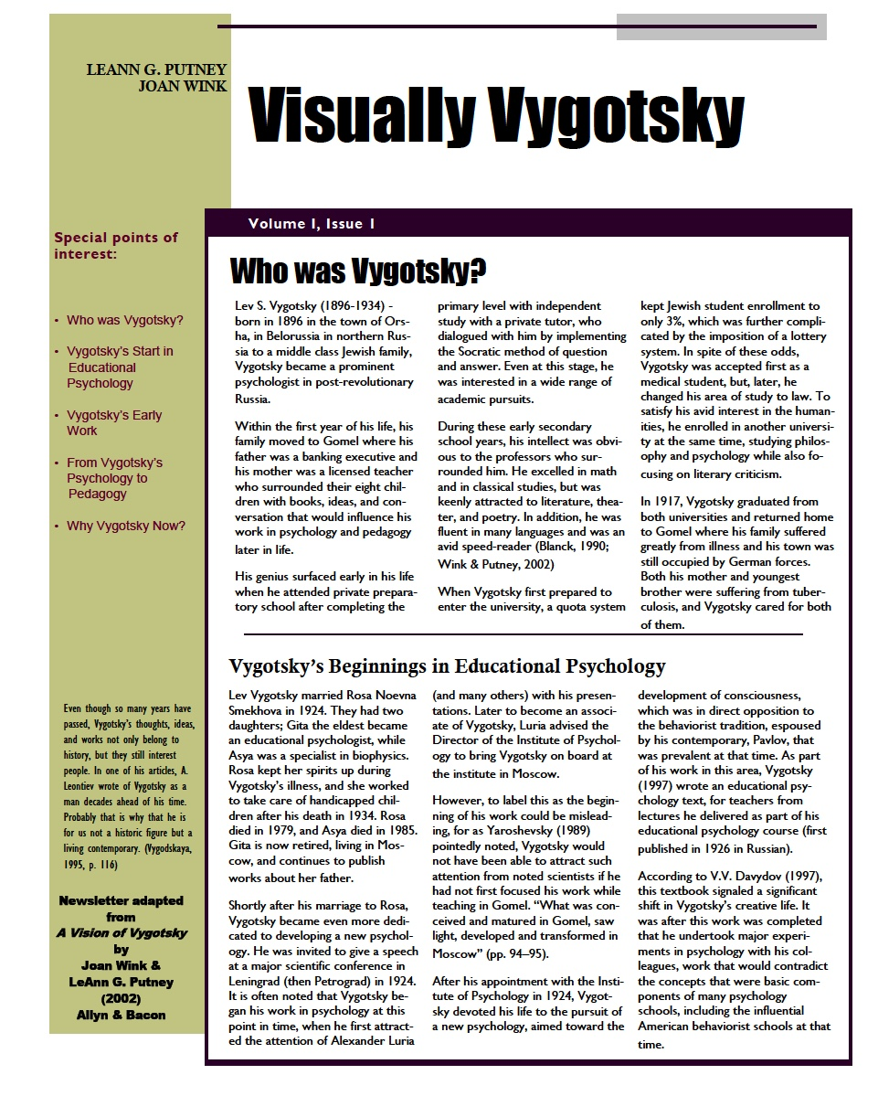

**HOW TO CREATE A NEWSLETTER**

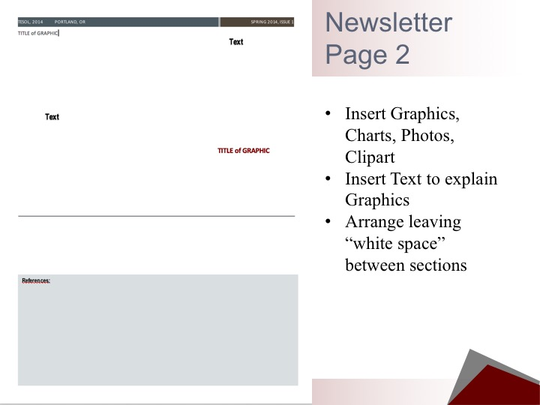

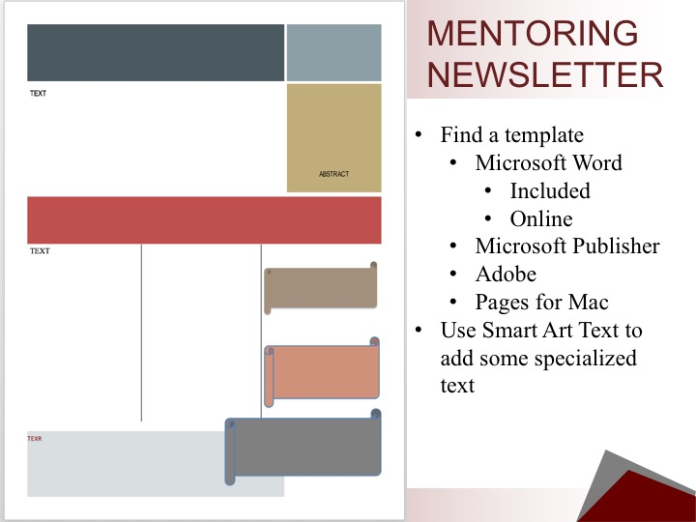

**REFEREN**

Putney, L.

To cite this presentation:

Putney, L. G., & Wink, J. (2019, Feb. 26). Reformulating Vygotsky’s principal principles into visual representation: Newsletters from the Field. Presented at *3rd Annual Conference on Academic Research in Education, Sponsored by UNLV, Las Vegas, NV.*

Previous References:

Putney, L. G., Wink, J., Scott, C., & Balatayo, J. (2014, March 28). Exploring Vygotsky: Reviewing a distant mentor for multiliteracy success. TESOL, 2014, Portland, OR. (This citation can be used for this presentation.)

John-Steiner, V., & Meehan, T. M. (2000). Creativity and collaboration in knowledge construction. In C. D. Lee & P. Smagorinsky (Eds.), *Vygotskian perspectives on literacy research: Constructing meaning through collaborative inquiry* (pp. 31–50). New York: Cambridge University Press.

John-Steiner, V. (2007). Vygotsky and linguistics: On speaking and thinking. The Cambridge companion to Vygotsky. (pp. 136-152). Harry Daniels, Michael Cole and James Wertsch (Eds.). NY: Cambridge University Press.

Wink, J., & Putney, L. G. (2002/2013). *A vision of Vygotsky*. Boston, MA: Allyn & Bacon. Now available at www.JoanWink.com.